Individual Logbook

Week 10
Dave Sushames
2026
Contents
Table 1
Discussion 1

Table
Category | Hours Completed
Team meetings | 5
Client meetings | 1h 15m
Advisor meetings | 5
Research | 2h 20m
Development | 4h 30m
Testing | 2h 45m
Documentation | 4h 15m
Logbook preparation | 1
Other
Total hours for this week | 26h 5m
Running total of hours completed for Capstone | 220h 50m

Logbook content notes
Team meetings:
Tuesday 9-2pm: Audited hourly logs, clarified upcoming meeting times. Arranged who would lead each presentation slide, made last minute refinements, did a practice run. Matt demo’d the foremost integration.
Client meetings:
Tuesday 2:30-3:45 Giving presentation to Geoff. Discussion about project progress,. Him giving us permission to do nmap/wireshark scanning on school network. Discussing AI’s limitations.
Advisor meetings:
Monday 8-10: Bryce gave advice for the presentation slides. Discussed inclusion of recent development in nMap. He showed how the network tunnelling through SSH could access his ollama server.
Monday 11-12: Meeting with Clement about presentation, as well as the project’s progress. Discussed mine and Sam’s missing weekly logs. Discussed how to document Olivia’s (PM) portion of the project.
Friday 9-11am: Meeting with Bryce about starting work on the poster and final client deliverables, self management review, version number updates, and what will happen with mine and Sam’s missing logs.
Research
See research log
Development
Spent some time figuring out how to set and adjust the gemma4:26b model’s parameters, especially setting the temperature to 0. Rebuilt the model as “gemma4-df” using the following parameters: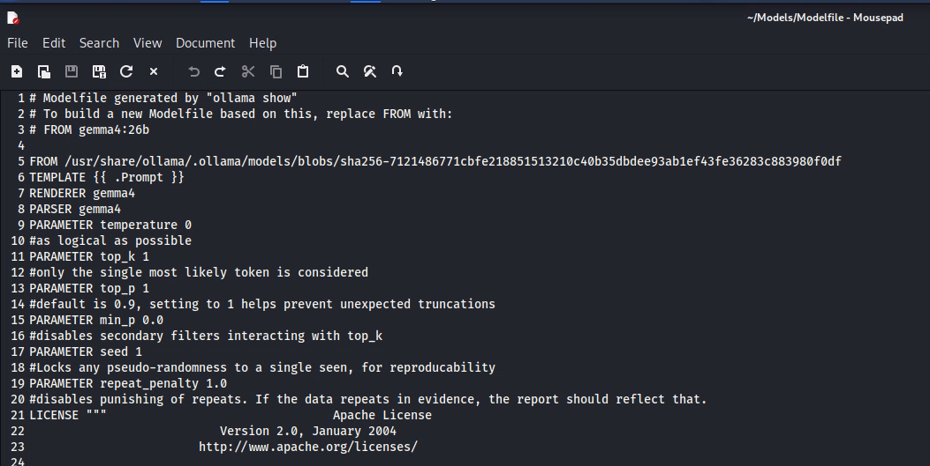
Encountered some issues with permissions, but solved it by adding a new group.
Ran the new model with Matt’s “Ninemost” foremost script, and continued work on a “Tenmost” script where it would attempt to use pdfcrack and steghide to extract encrypted information. In a communication with Bryce, he said this would be more of a stretch goal, so not needed at the moment.
Working on fixing the scripts to fix the end of line ANSI characters.
Testing
Running Nmap scans on my local machine, trying to get a handle on how it works, and how it is useful. 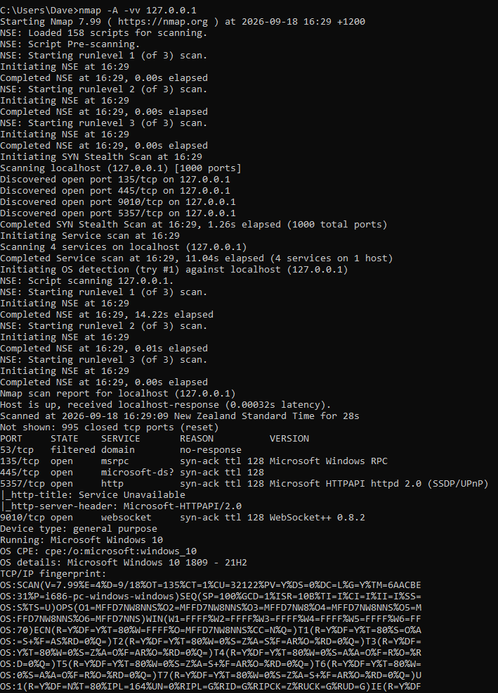
Nmap scans seem to take a very long time, depending on what you’re trying to get them to scan. 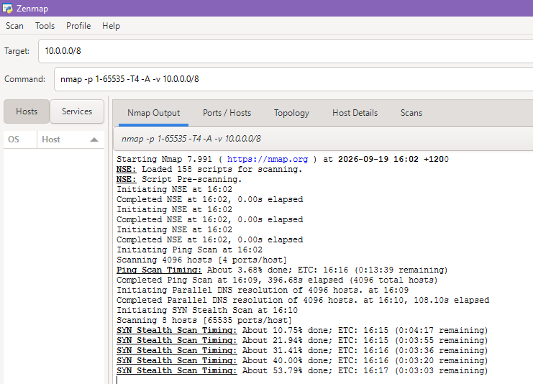
Managed to get an Nmap scan to export to a .txt file
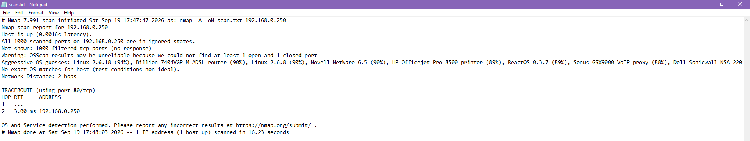
Documentation
Finalising the Mid-project presentation, doing a final pass on formatting.
Started work on the poster for the final panel. Deciding the sections that information would be laid out in.

